|  |  |  |  |  |  |  |  |  |
| --- | --- | --- | --- | --- | --- | --- | --- | --- |
| **MAD Project Evaluation 1 – Regular Intake 2021** | | | | | | | | |
| **Group Name:** | <Add the group name you registered with> | |  |  | **Batch:** | 7.1 | | |
| Student ID | Student Name | Consistency (Out of 2) | Appropriateness and Professionalism (Out of 3) | Usage of resource manager (Out of 4) | Out of box design ideas (Out of 3) | Report (Out of 8) | Total (Out of 20) | Comments |
| IT20222086 |  |  |  |  |  |  |  |  |
| It20008246 |  |  |  |  |  |  |  |
| IT20116460 |  |  |  |  |  |  |  |
| IT20087456 |  |  |  |  |  |  |  |
|  |  |  |  |  |  |  |  |

Git Repository Link:

(If already created)

----------------------------------------------------------------------------------------------------------For Evaluators use only---------------------------------------------------------------------------------------------

Evaluator’s name:

Others:

1. Introduction to the project

Bees Courier is the largest and most experienced Domestic Courier Service Company in the Island handling time sensitive documents and packages for corporate and individual clients for over 5 years.

Over the years it has harnessed its dedication and devotion towards the customer concerns. Its services and operational systems are tailor made which could cater to the varying needs of the customers.

Speed, Security, Reliability and Accountability are considered paramount in its services afforded to every customer

Cash on delivery (COD) payment for your goods upon delivery, this payment will be collected by Pronto on behalf of the client.

We offer our services to cater to all your e-Commerce logistic requirements at a very nominal rate. We ensure rapid delivery and a high quality service to maximize the efficiency of your turnover and satisfied customers.

Bees carries your parcels and packages to any destination of the country within the shortest possible timeframe. Bees send their staff and vehicles to any destination to complete your delivery requirement. It is a cost effective solution to send and receive documents/packages island-wide, After completion of delivery, a proof of Delivery Documents (POD) will be available to the customer to ensure that your parcels/documents are dealt with utmost care.

**Individual Contribution**

IT20116460

* Add package details
* Add pick up details
* view and edit pickup

It20008246

* Payment details and calculation

IT20222086

* Customer Profile (Add, update, delete customer profile)
* Order list (retrieve order list of the customer from database)
* Order Details (View detail and check status)

IT20087456

* Customer reviews

UI Connections

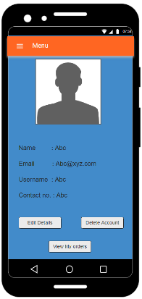 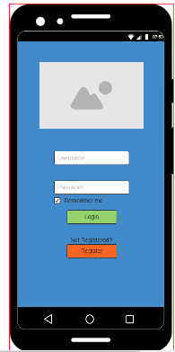 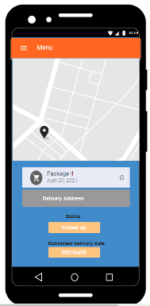

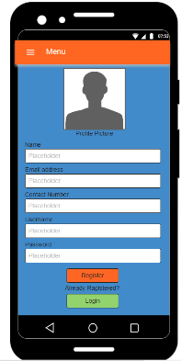 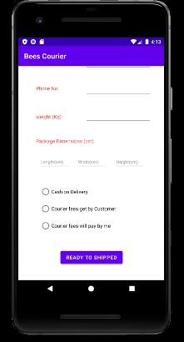 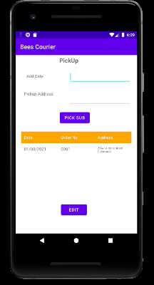 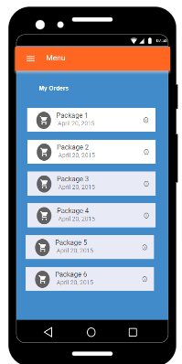 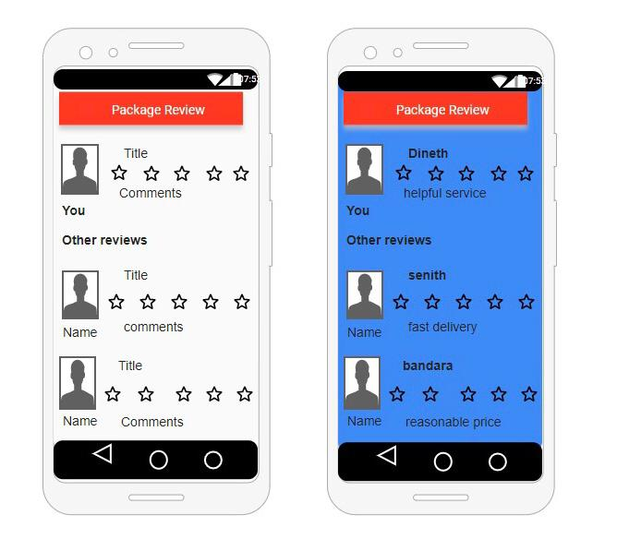

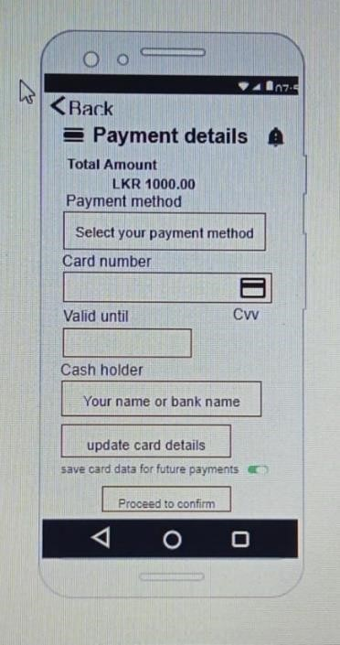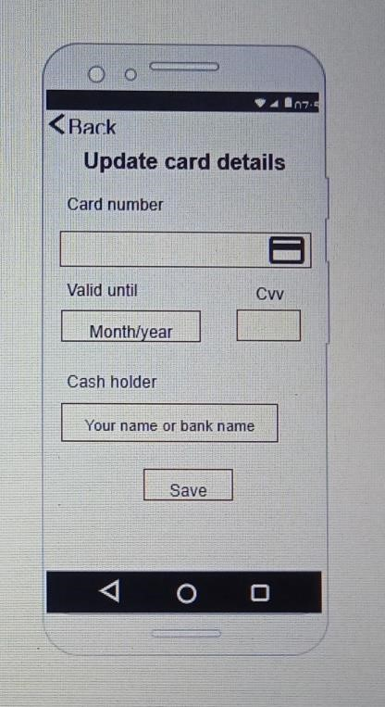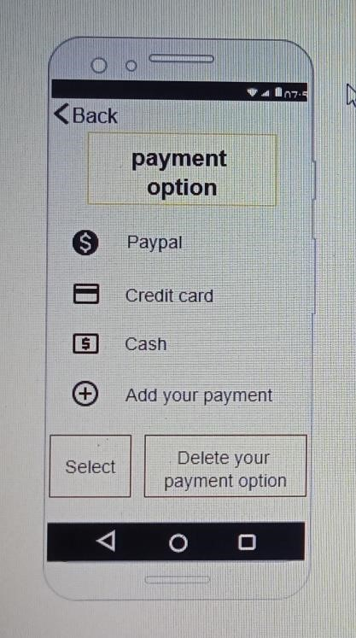

**IT20222086 Customer Profile, Order list Order status**

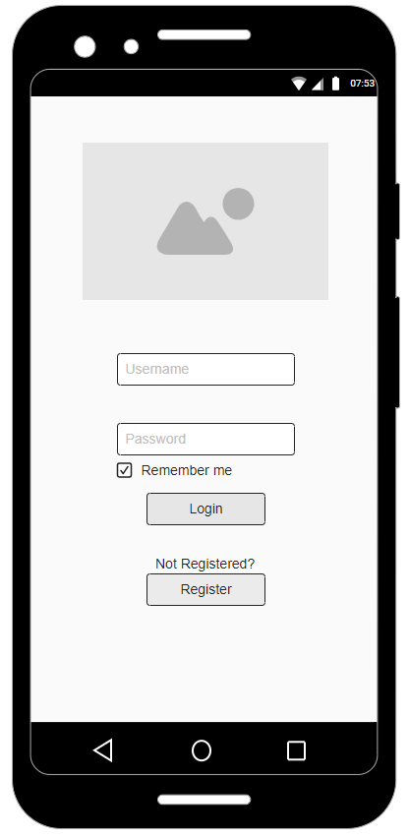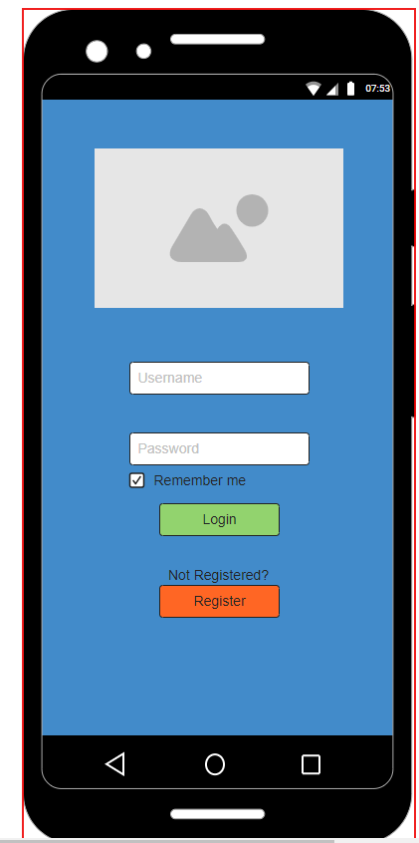 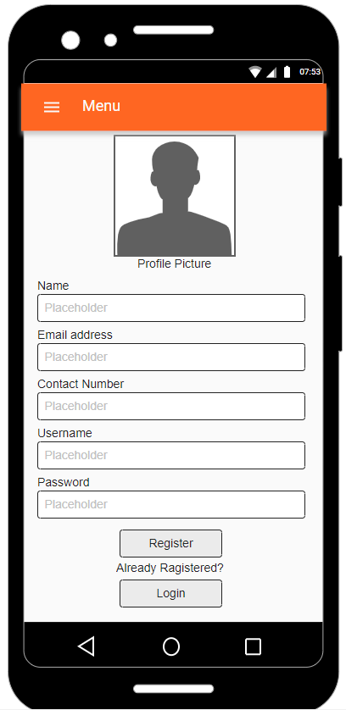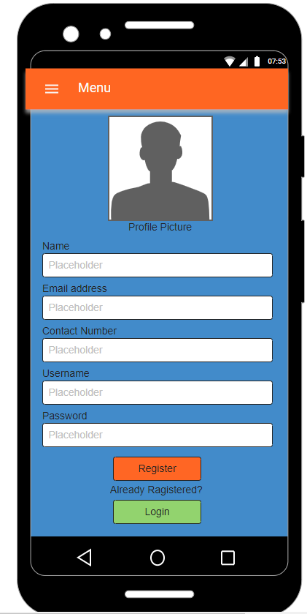

In here they can register or again go back to login page. after registering they are directed to their profile page.

This is the first page that customers see when they open the app.

If clicked register then they are redirected to the following page.

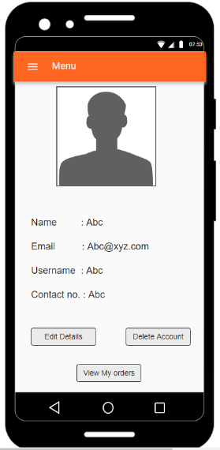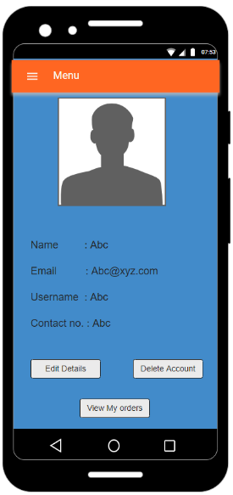 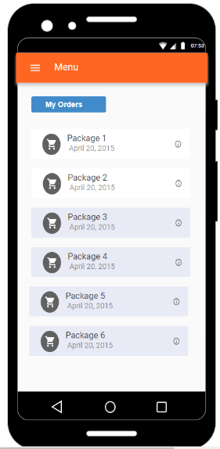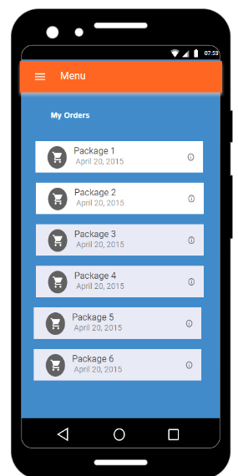

In this page they can see their previous orders and current orders. If they click on an order, they will be taken to order status page.

In here they can see their profile and they can edit, delete their profiles.

Also, they can view their orders by clicking view my orders button.

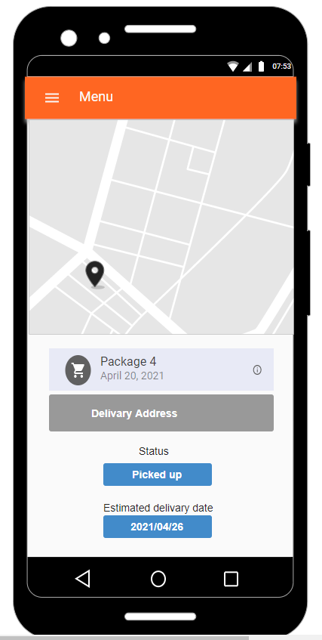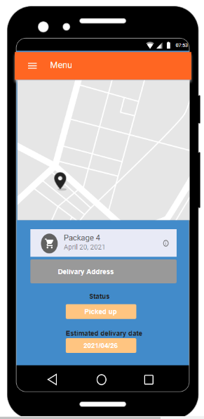

In this page you can see the order detail,

status of the order as well as the estimated delivery date calculate.

**Resource usage**

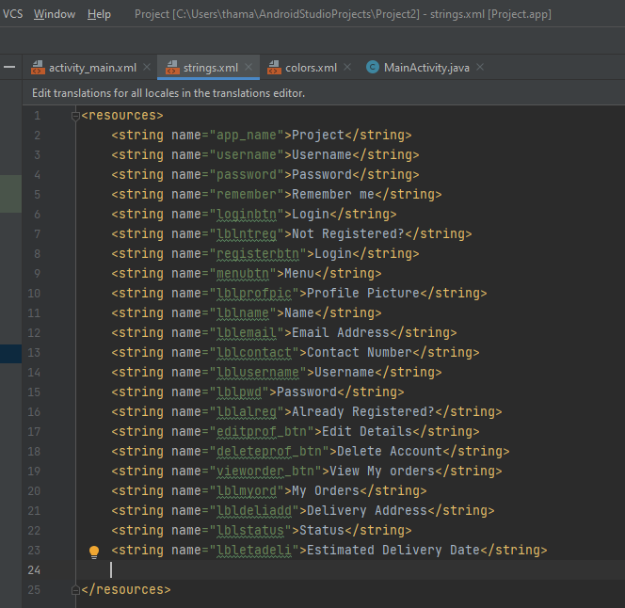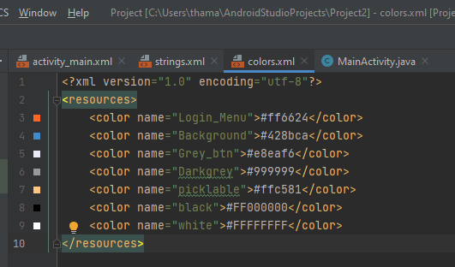

**CRUD operations and the functionality of the components**

In our system every customer is registered and has to login to use the system so that they can track their orders. Customers have their own unique profile and can change details anytime they want. If they wish to delete their account, we will ask for a confirmation again and delete the account permanently. They can see the details of their orders by visiting my orders page through the menu button or from their account page. In my orders page they can see all their orders and it will show the orders completed and not yet completed in different colors to customer to identify them easily. If they want to see the details of any order it can be seen by clicking on an order, then they will be directed to order details page where it will display the details of the order like the delivery address and the status of the order which is updated whenever the status is changed and the estimated delivery time which is calculated using average delivery time and adding extra day if there were any delays.

**IT20116460 – Add package details, Add pickup, view pickup, edit pickups**

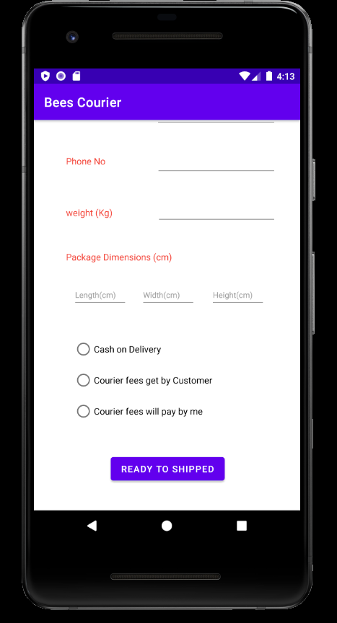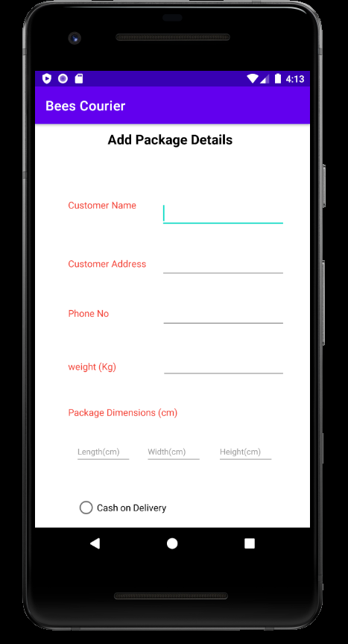 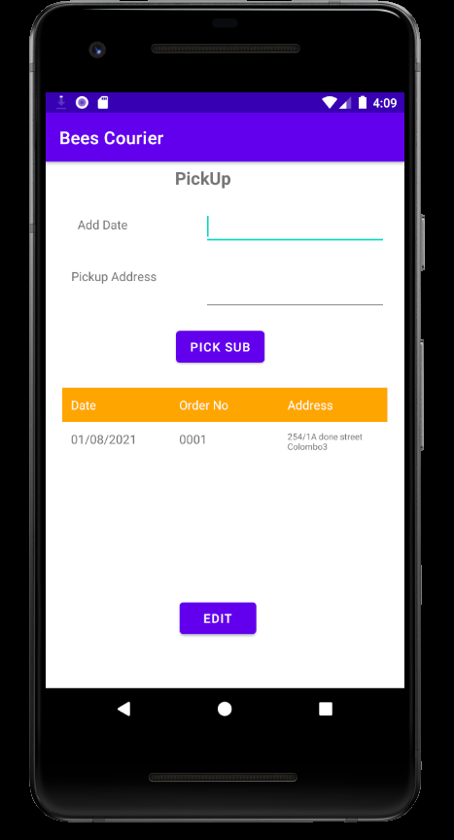

The customer should be directed to the details

of the package they are going to send.

Customer can add their pick up address and date to identify us to get their package and customer can see their pending pickup orders and can edit any time these details.

Usage of resource files

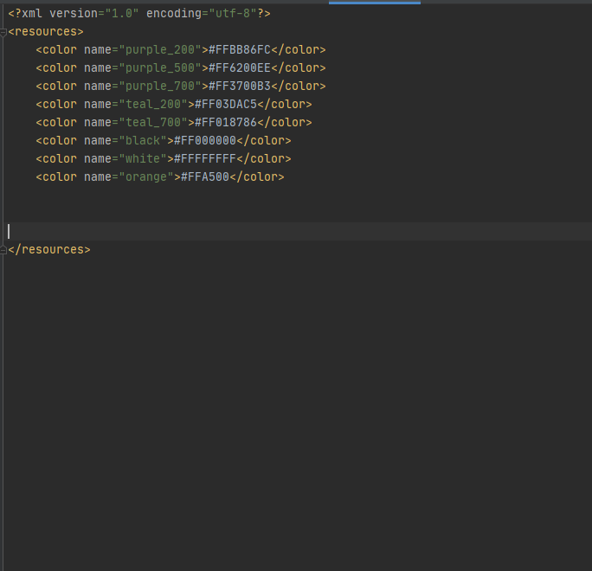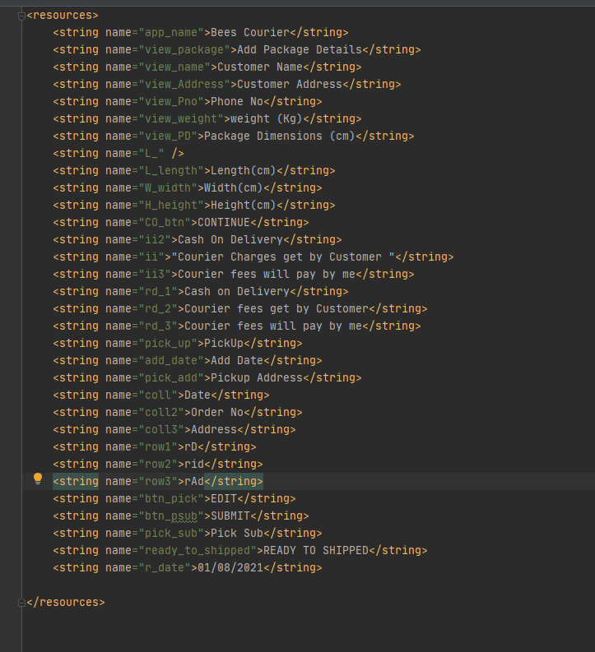

CRUD Operations and functionality of the components:

The customer has to fill in the details of the package they are going to send and enter the sender's name, address and telephone number one by one and then give the weight and size of the parcel.

Also, if you have already received the money in this parcel, you should get the information whether the courier will receive the fee from the sender or the customer will pay for it. It should also be mentioned if you are eligible for cash on deliver.

**It20087456 Customer reviews**

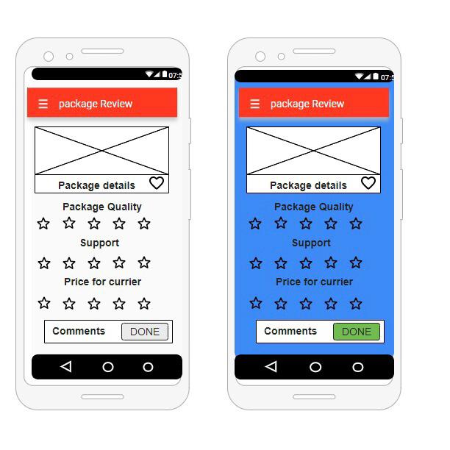 

After the customer review page, they can look at their own reviews and other person’s reviews. New users can get idea about quality of the application in this page.

After customer got package he can give their reviews

here and they can give ratings for package quality,

support and price for courier

**Resource Usage**

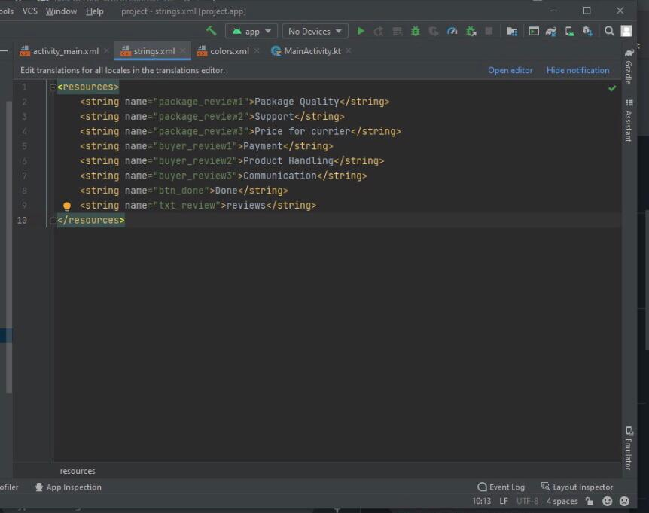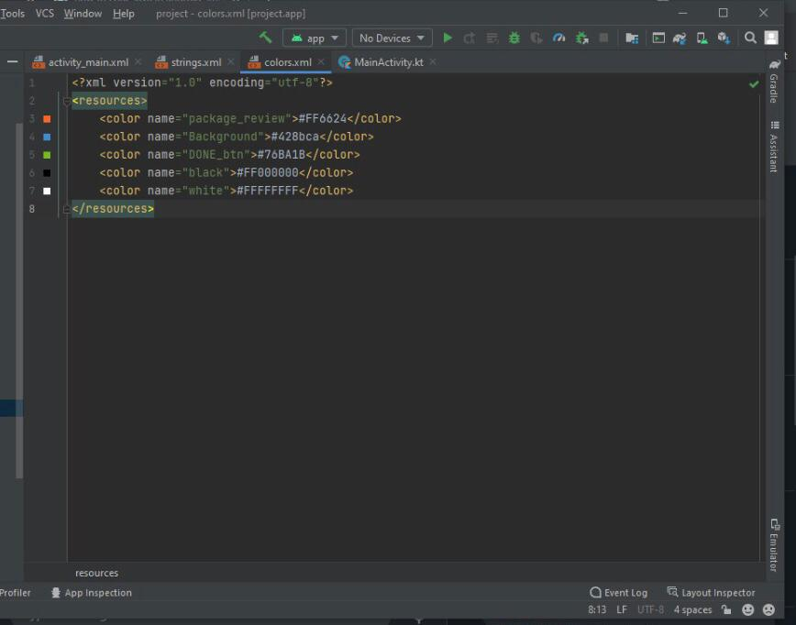

# IT20008246; Payment Option, Payment Details and Update Card Details Payment option



Customer can choose the payment option and select it.

Also customer can Delete your payment option in this page.

This is the Payment details page that customer sees when they open the app and scroll down.

If clicked and fill, then they are redirected to the following page.

Lastly customer can Proceed confirm Payment Details.

*In this page you can update

card details as well as save the details.

.

# Resource Usage

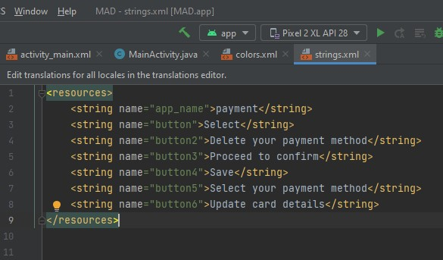 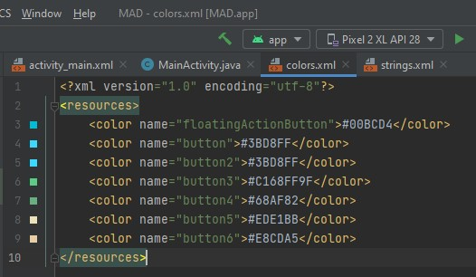

# CRUD Operation and the functionality of the components

In our system every customer is registered and has to login to use the system so that they can track their orders. Customers have their own unique profile and can change details anytime they want. If they wish to delete their account, we will ask for a confirmation again and delete the account permanently. They can see the details of their orders by visiting my orders page through the menu button or from their account page. In my orders page they can see all their orders and it will show the orders completed and not yet completed in different colors to customer to identify them easily. If they want to see the details of any order it can be seen by clicking on an order, then they will be directed to order details page where it will display the details of the order like the delivery address and the status of the order which is updated whenever the status is changed and the estimated delivery time which is calculated using average delivery time and adding extra day if there were any delays.